**SPRINT 3 DELIVERABLES**

1. **We have created a**[**report**](https://github.com/IBM-EPBL/IBM-Project-14297-1659548839/blob/main/project%20development/sprint%203/contact.html)**page for users to send their queries and feedback to us.**

**[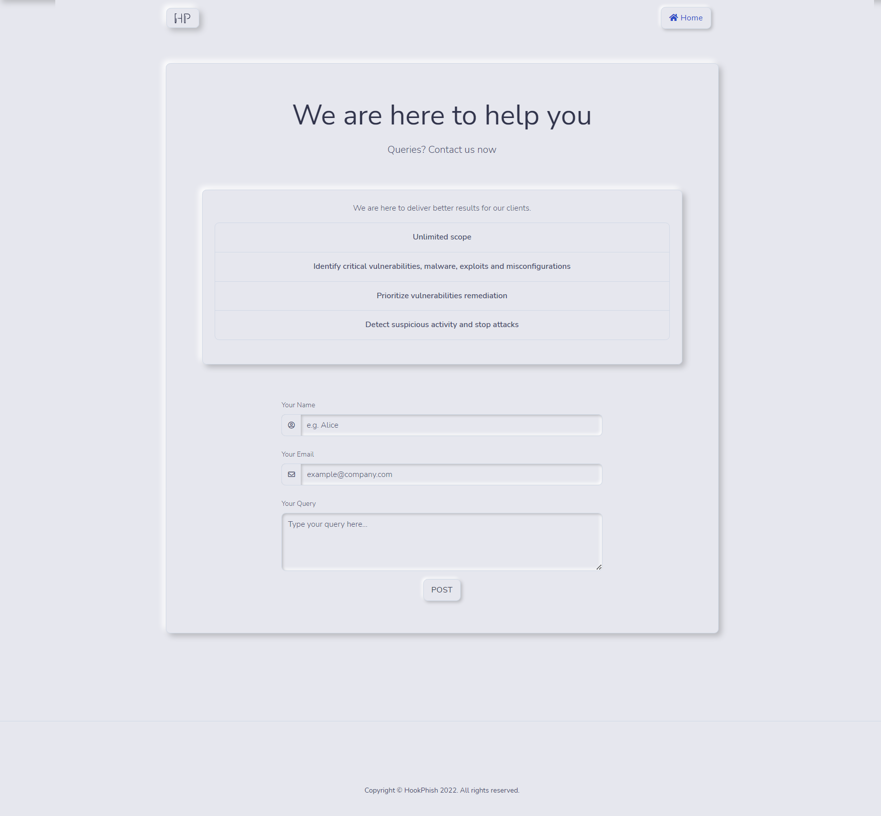](https://user-images.githubusercontent.com/64459672/200650141-f2ceac85-0f16-4662-b9aa-c4f206b6a50f.png)**

**[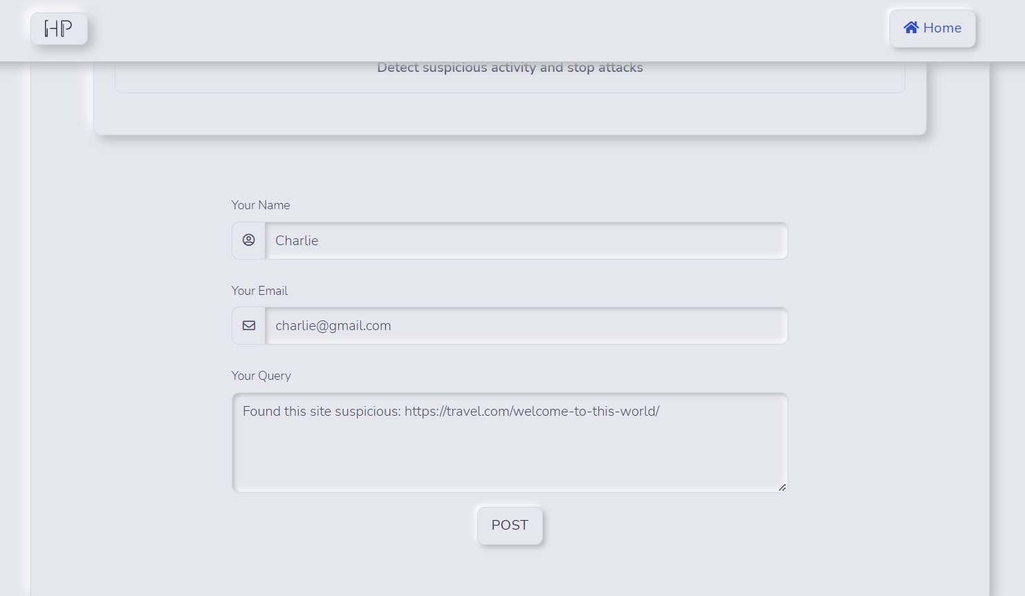](https://user-images.githubusercontent.com/64459672/200650159-062c804b-3e56-4a68-869b-8b5e3c0d6c7d.png)**

**[](https://user-images.githubusercontent.com/64459672/200650177-0f900e57-fac7-4bbd-af57-c5507bb75dc6.png)**

1. **We created a MySQL database and integrated with our**[**application**](https://github.com/IBM-EPBL/IBM-Project-14297-1659548839/blob/main/project%20development/sprint%203/app.py)**to store all the responses.**

**[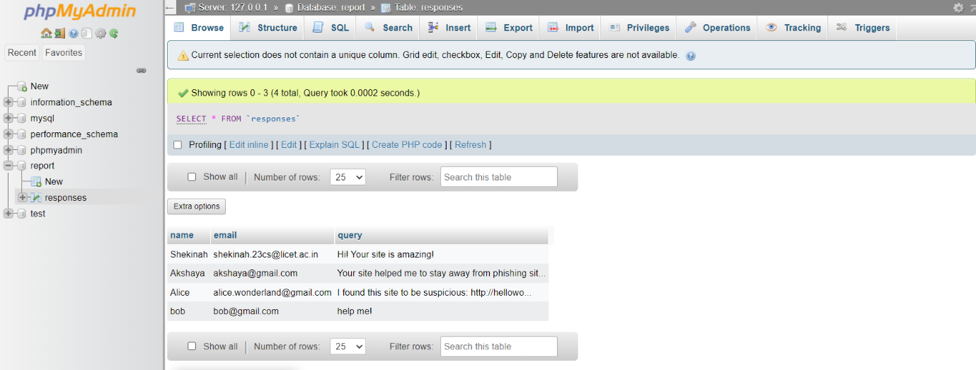](https://user-images.githubusercontent.com/64459672/200648674-80bd8f4d-c5ee-40d2-b814-953f1818e682.png)**

**Footer**